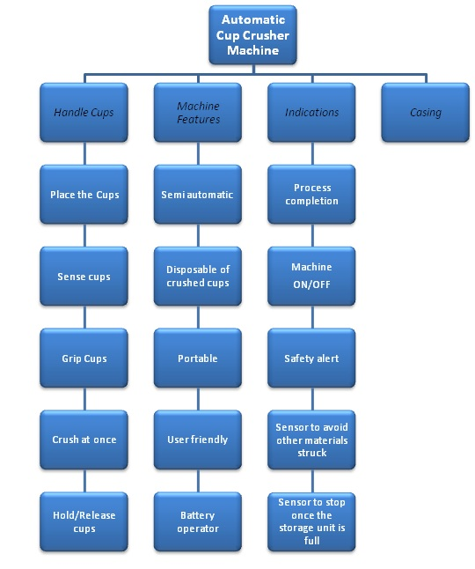

**CUP CRUSHING UNIT**

CASING

**INTERFACE UNIT**